- Read over information from TeensHealth to learn what makes a meal healthy. Pay close attention to the part of the article that explains how many calories we should get from fat in our meal.
We will be using this information to create charts that will help us evaluate how healthy our meal is.

- Now use this handy nutrition calculator to determine how many calories you need each day. Once you have determined how many you should consume in a day, be sure to write it down in your notes so you don't forget it.

- Decide which fast food restaurant you would like to visit. Click on that restaurant's web site below. Once there, create a meal with a sandwich, salad or other main dish, a side dish (French fries, etc.), a drink, and a dessert. For each item on your menu, record the total calories, the calories from fat, and the total grams of fat on the chart below.

- Add: In column E –non Fat Calories and column F - % of calories from Fat

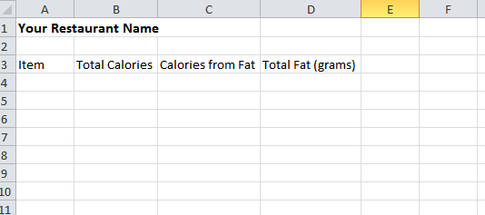

- Add: In column E –non Fat Calories and column F - % of calories from Fat

- Now go to Google sheets and create this chart.

- Name it : Fast Food Fun

Now we will start doing the calculations

- Column E ---- How to do the formula for non-fat calories and auto fill.
Watch this tutorial to use formulas to easily complete Column E.

http://www.lifeinthetechlab.com/Lab_Fourth/fourthSpreadsheets/FFFun/FastFoodFun.php

- The last set of calculations you'll need to do is total your columns. Do the following for every column except the Percentage from Fat column.
Watch the video of this step.

First, select the cell under the column you wish to total up. | 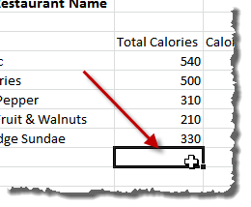 | Second, click the Autosum button on the Ribbon (Home tab). | 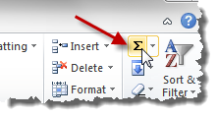
Third, make sure the range of cells is correct. Look for the dotted lines and make sure it includes the whole range of cells! | 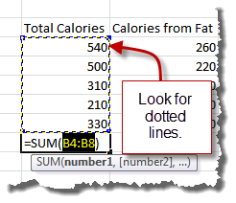 | Fourth, press enter to lock in the function and see the total. | 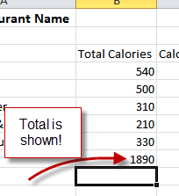
- After you have done this for each of your columns, your spreadsheet should look similar to the following (you'll see I've also formatted my table):
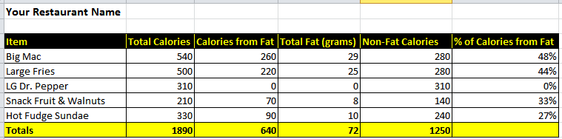

- Column F -- Percentage of calories from Fat---
Watch this tutorial to use formulas to easily complete Column F
*When it gets to formatting in % stop and follow directions below*
http://www.lifeinthetechlab.com/Lab_Fourth/fourthSpreadsheets/FFFun/FastFoodFun.php

*To format COLUMN F Select cell F2 go to format in the top menu. Click Numbers in the drop down then choose %. Click enter.
Then go to the right hand corner and pull down as directed in video to auto fill the rest of the column.

Step 5: Create Your Charts
Charts help us quickly see and process information visually. This is important as you try to convince people of the nutritional value of your meal.
Your final product must include at least two charts. Watch the videos below to learn how to create a bar chart and a pie chart. See several other sample charts you might also want to create.

Bar charts are useful when comparing the same thing in many different things. In this chart, you will use a bar chart to compare the fat and non-fat calories of each item on your menu. You can then quickly spot the choices that aren't healthy and point them out to your audience.
Click to watch the video explaining how to create this chart.
When you have completed this chart it should be similar to the following:
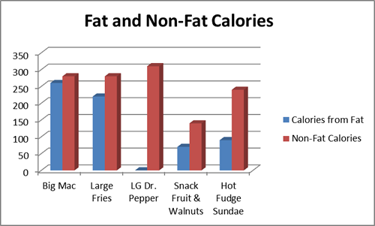

Pie charts are useful when you want to show how the different parts of a whole compare to each other. In this chart we will compare the calories from fat and the calories that are non-fat and see how they compare to total calories. We know that in a healthy meal the calories from fat should be less that 35%, so this chart will very quickly reveal the nutritiousness of this meal.
Click to watch the video explaining how to create this chart.
When you have completed this chart it should be similar to the following:
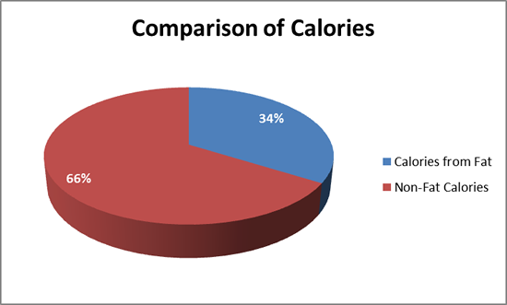
re are a few other sample charts you can create. Use the techniques learned to create the bar and pie charts in the other tabs of this section as you create these!
Chart 3
This chart uses a doughnut chart to show how many calories each item has compared to the calories in the whole meal. You can quickly see that most of the calories come from the Big Mac and the fries! We also finally see that while the Dr. Pepper may not have much fat, it sure does pack some calories! 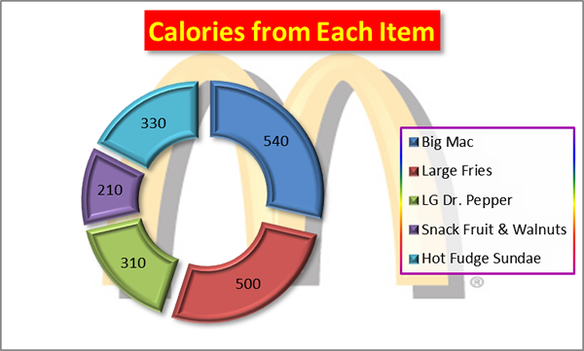

Chart 4
This chart uses the bar chart, which is very similar to the column chart to show the total grams of fat in each item. I used pictures of each item to make a stacked pictorial chart to add interest. This chart continues to point out that the Big Mac and the fries are the least healthy selections in this meal.
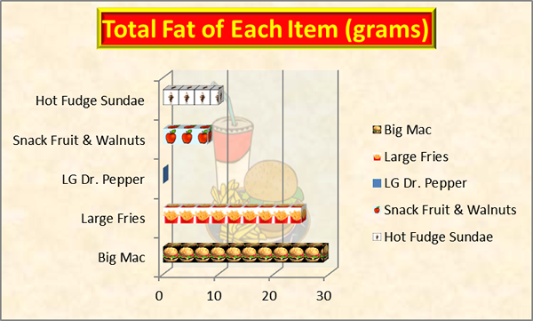
When your project is complete, it will include the following elements:
The name of your restaurant.
A nicely formatted table with each menu item and the following information about each:
Your table must include a row that totals each column as well.
At least one logo or graphic from your restaurant.
At least two charts that help you justify the nutritious value of your meal.
A three or four sentence paragraph that explains why your meal is healthy or not healthy. You must use data from your spreadsheet to justify your explanation!
YOUR NAME! Be sure to take credit for your work!!
RUBRIC
Fast Food Fun | To earn a NI- you must complete the following: | To earn a NI you must complete the following: | To earn a S you must complete the following: | To earn an E you must complete the following:
Target Objective 1  Manipulate a spreadsheet: enter and format data and use formulas and functions. | Level 1 Indicator  Entered most data correctly, some incorrect formatting, attempted to use formulas and functions | Level 2 Indicator  Entered all data correctly, was able to format data, attempted to use formulas and functions | Level 3 Indicator  Entered all data correctly, completed required formatting, used formulas and functions correctly | Level 4 Indicator  Entered all data correctly, completed required formatting, used formulas and functions correctly, used advanced formatting techniques to design spreadsheet
Target Objective 2  Create bar charts to analyze data  . | Level 1 Indicator  Created minimal charts lacking correct chart elements; incorrect data displayed | Level 2 Indicator  Created minimal charts lacking correct chart elements; correct data displayed | Level 3 Indicator  Created required charts with correct elements including title, names of axes, legend, and data labels; correct data displayed | Level 4 Indicator  Created required charts with correct elements including title, names of axes, legend, and data labels; correct data displayed; used advanced charting techniques to design charts beyond requirements
Target Objective 3  Create pie charts to analyze data  . | Level 1 Indicator  Created minimal charts lacking correct chart elements; incorrect data displayed | Level 2 Indicator  Created minimal charts lacking correct chart elements; correct data displayed | Level 3 Indicator  Created required charts with correct elements including title, legend, and data labels; correct data displayed | Level 4 Indicator  Created required charts with correct elements including title, legend, and data labels; correct data displayed; used advanced charting techniques to design charts beyond requirements
Target Objective 4  Summarize findings using a word processor and incorporating data and charts from spreadsheet  . | Level 1 Indicator  Able to copy chart from spreadsheet; brief summary with few details; no attempt to draw conclusions about data; did not meet requirements for length; did not used correct format | Level 2 Indicator  Able to copy chart from spreadsheet; brief summary with few details; some attempt to draw conclusions about data; made some attempt to meet length and format requirements | Level 3 Indicator  Able to copy chart from spreadsheet; summary included required details; was able to meet length and format requirements | Level 4 Indicator  Able to copy chart from spreadsheet; detailed summary with additional information beyond required elements; met or exceeded length and format requirements

